2.17: a) Assuming the car comes to rest from 65 mph (29 m/s) in 4 seconds, 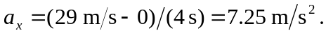
b) Since the car is coming to a stop, the acceleration is in the direction opposite to the velocity. If the velocity is in the positive direction, the acceleration is negative; if the velocity is in the negative direction, the acceleration is positive.

